Jenkins Installation and Configuration

And Project Configuration

**What is Jenkin’s?**

Jenkins is a self-contained, open-source automation server which can be used to automate all sorts of tasks related to building, testing, and delivering or deploying software.

Jenkins can be installed through native system packages, Docker, or even run standalone by any machine with a Java Runtime Environment (JRE) installed.

**Prerequisites**

* **Install java and Set environment path - Java Version (11/17)**
* **Install Git and GitHub desktop check Version of Git**
* **Install Maven and Set environment path check Version of maven**

Minimum hardware requirements:

* 256 MB of RAM.
* 1 GB of drive space (although 10 GB is a recommended minimum if running Jenkins as a Docker container).
* JAVA 11 or 17 version need to be installed.

Recommended hardware configuration for a small team:

4 GB+ of RAM

50 GB+ of drive space

1. **Download and Install Maven and Java in your Machine and set Environment path as shown.**

**Maven and Java Environment setup**

**Jenkin Installation:**

**Download Jenkins LTS for:**

[**https://www.jenkins.io/download/**](https://www.jenkins.io/download/)

**Download the Jenkins from above link**

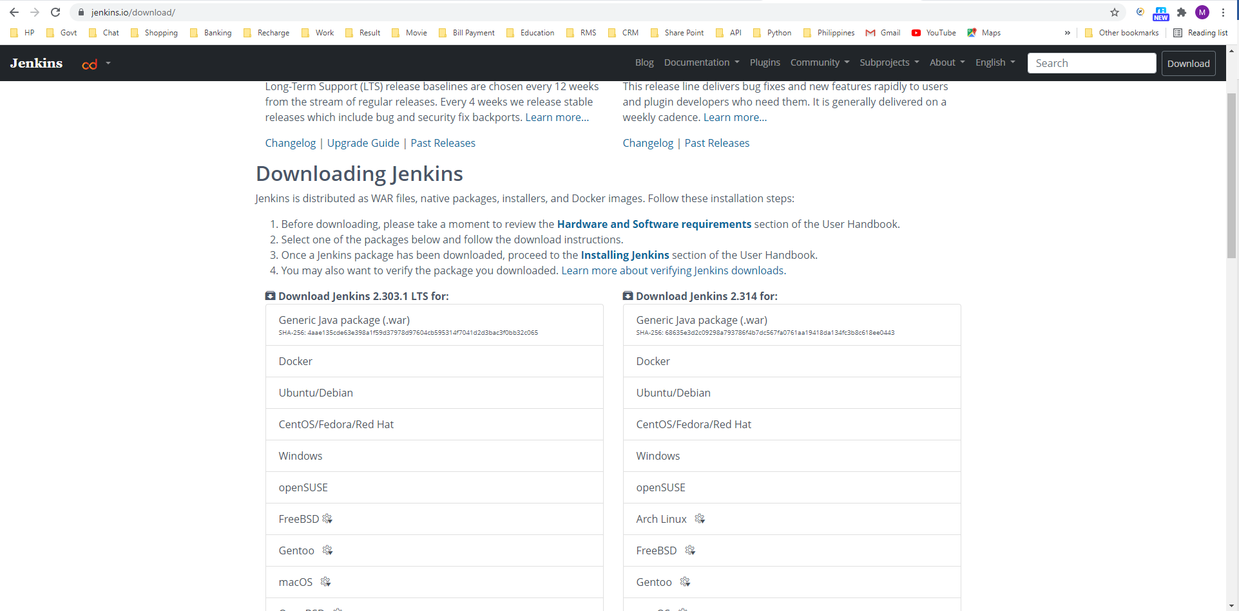

**After Download Double click to install the Jenkins**

**The prompt will open and shows the path of the Jenkins to be installed**

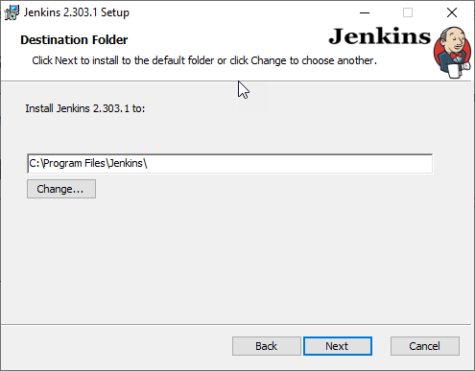

**Service Logon Prompt will open click on Run Service as Local System**

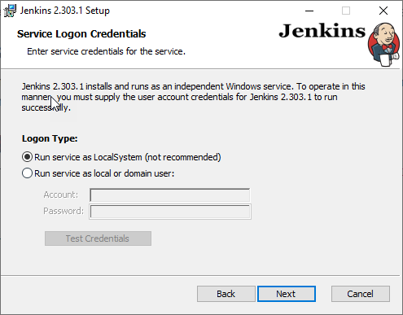

**Port selection port will open select your desire port and click test port**

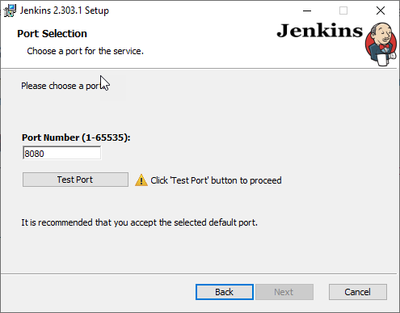

**If the port is available, the tick mark will display as green**

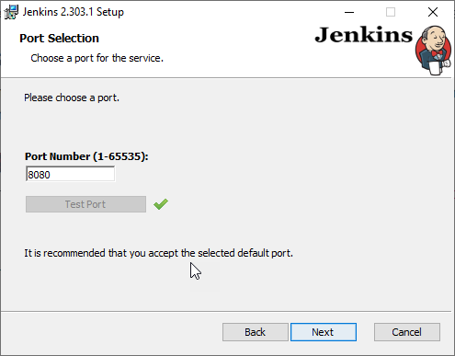

**Then the next prompt opens with the java installation path ensure the path of the jdk is correct also ensure Java version**

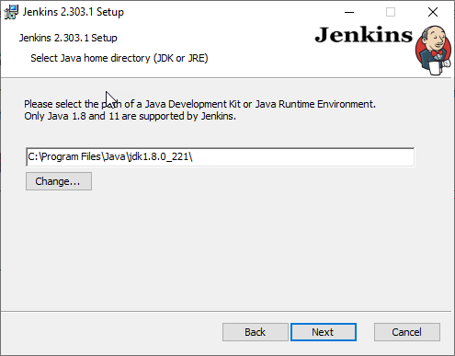

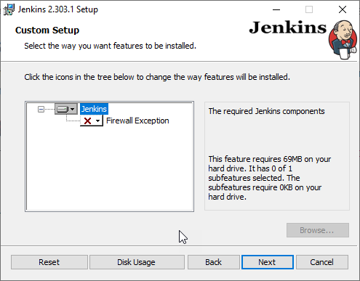**if Jenkins shortcut required select from the fire wall exception and click next**

**Click install to install Jenkins**

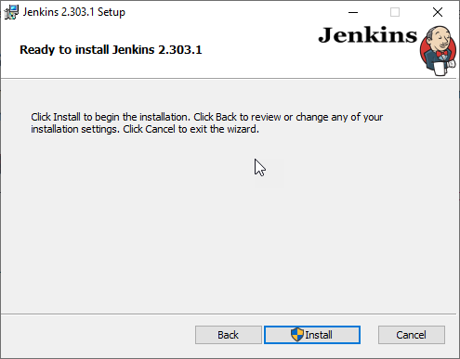

**Once after installed the finish prompt opens click on finish**

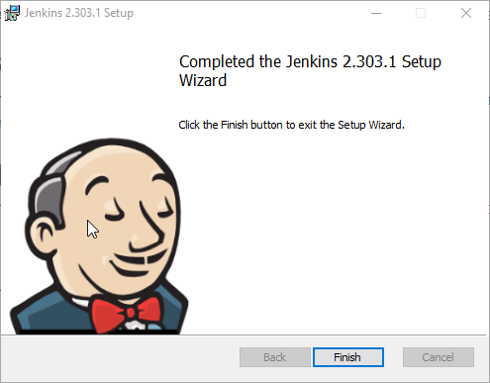

**After click on finish unlock Jenkins prompt will open from the mentioned path in the prompt admin password will be available**

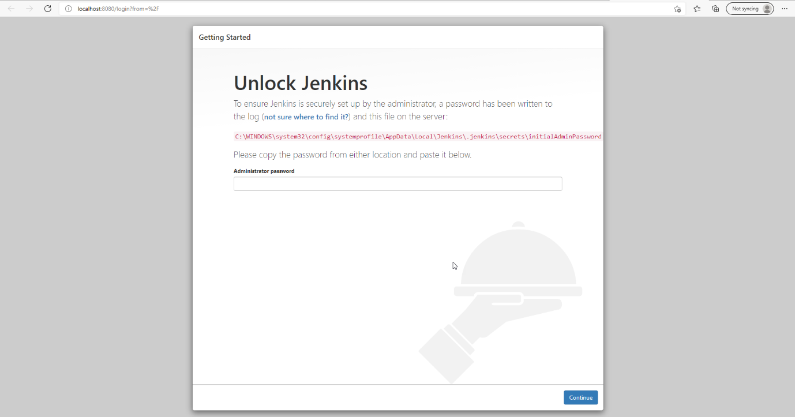

**Copy the password from the initialAdminPassword and enter in the unlock Jenkins prompt**

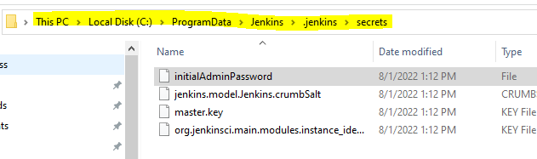

**Then install suggested plugins in the customize Jenkins prompt**

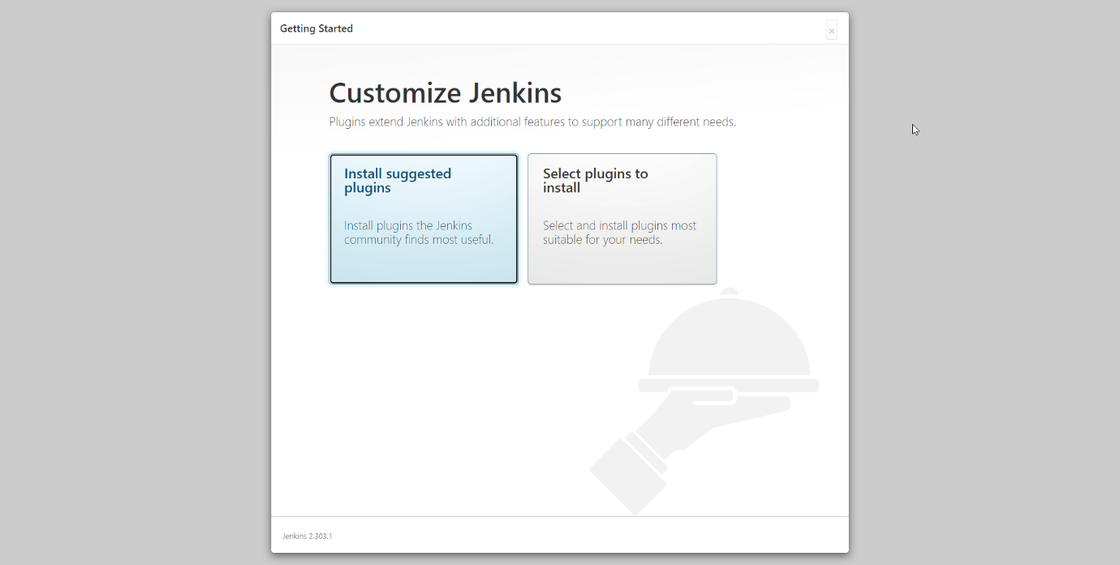

**Plugin’s need to install initially**

**After selecting click Install and installation starts as shown**

**After Installation of Plugin’s, If needed we can create user or we can skip and continue as admin.**

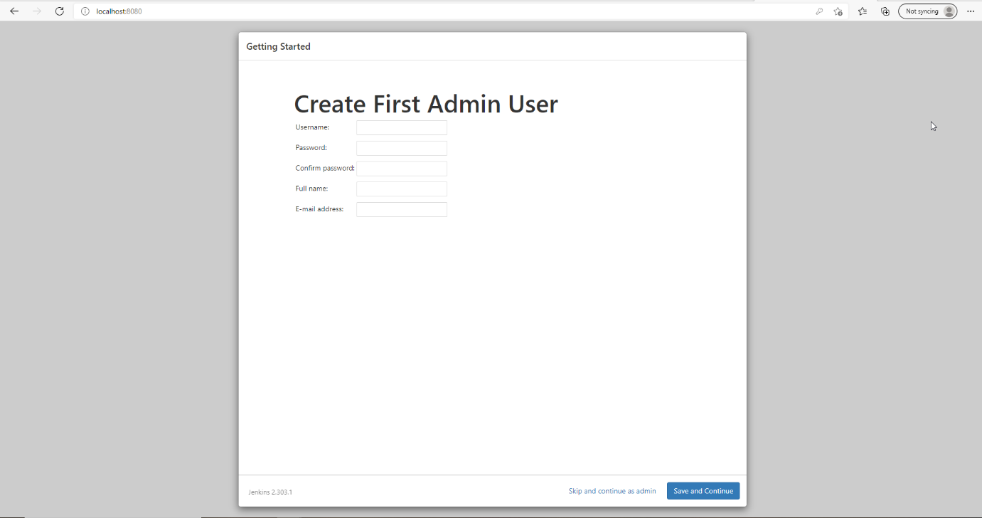

**Then it will prompt Instance configuration it will display the Jenkin URL, click save and finish**

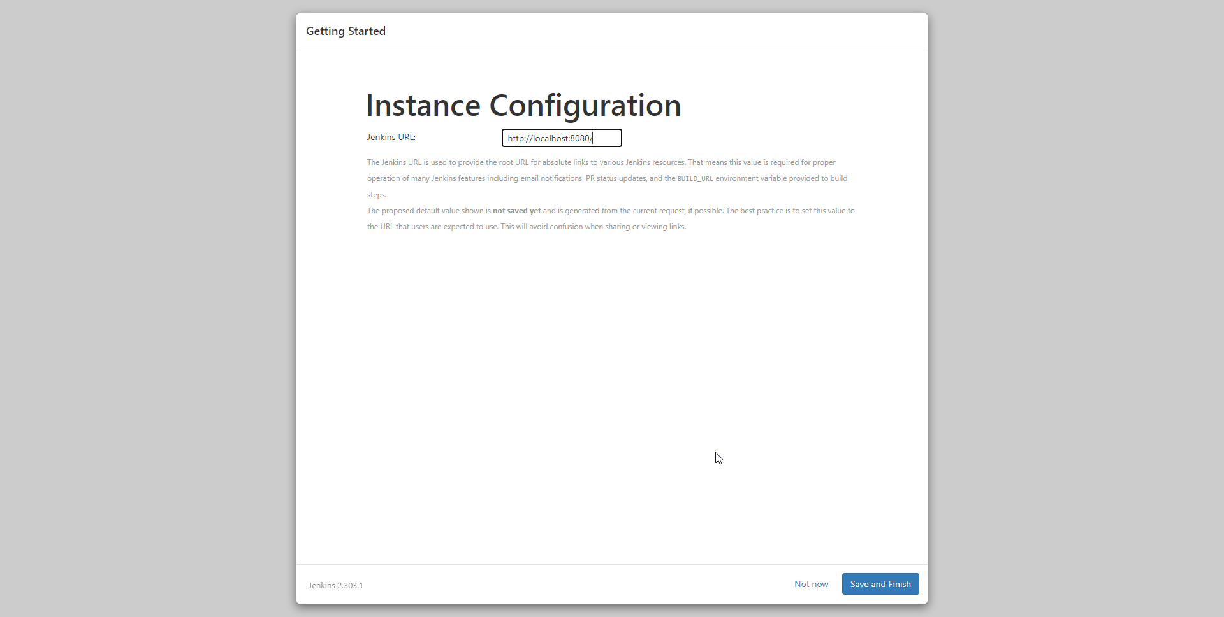

**Once after the plugins installed click start using Jenkins**

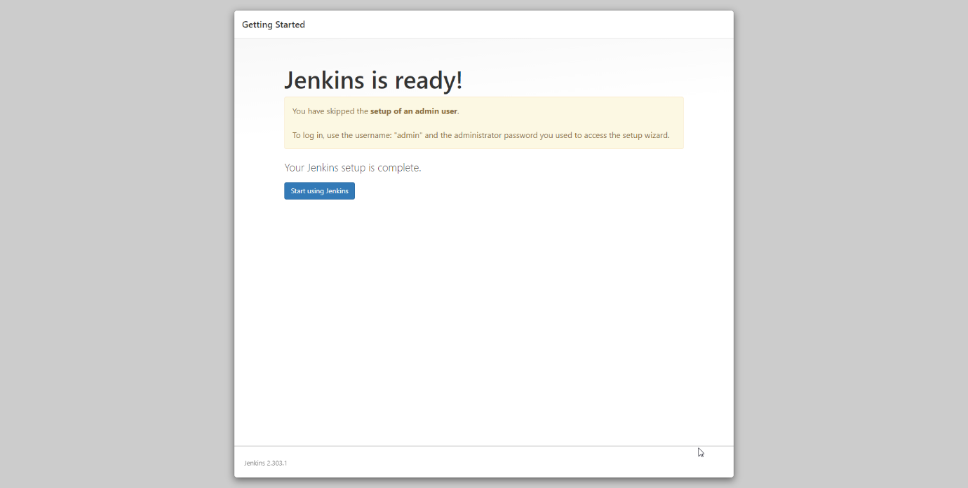

**Jenkins home page will open**

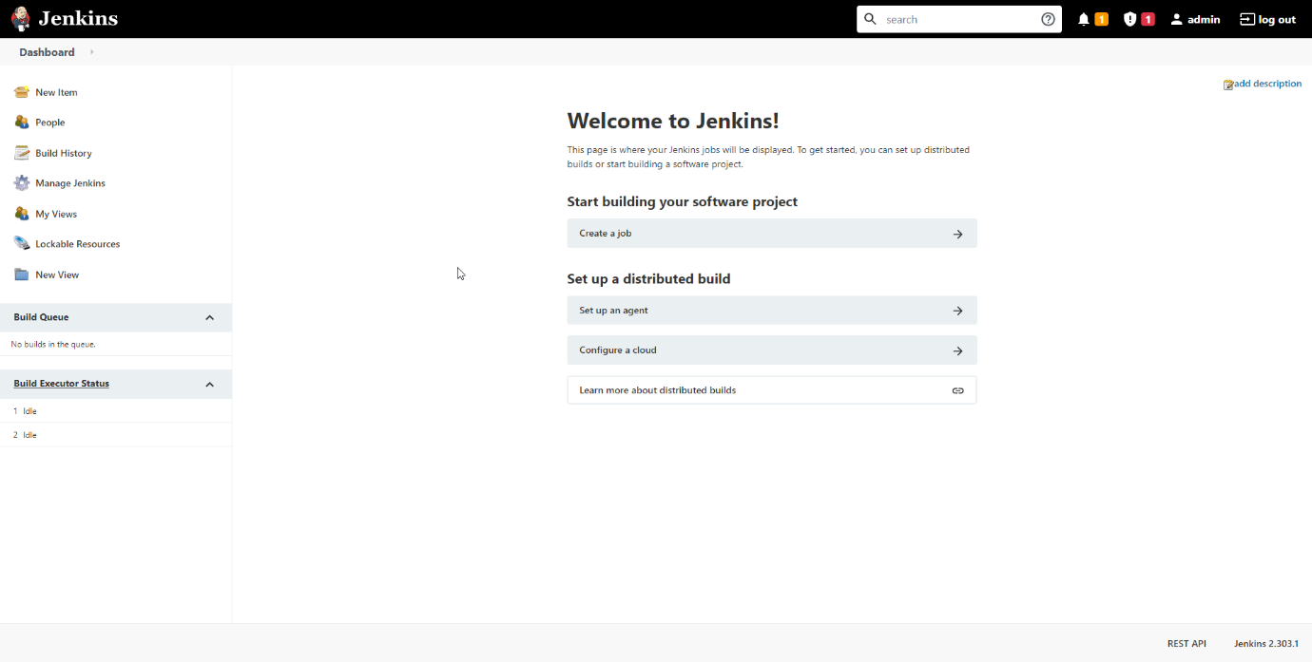

**Jenkins Configuration and Installation done….**

**Configurations need to be done before adding project**

**Click on Manage Jenkin’s**

**Select Global Tool Configuration**

**Click on Install JDK and Add your system variable name and JDK path**

**Click on Install Git and Add git exe path**

**Click on Install Maven and Add your system variable name and Maven path**

**Let us go for Project configuration now.!**

**Project Configuration with GitHub**

**Select new Item from Dashboard**

**Enter Name for reference and Select Maven Project and click Ok**

**Configuration**

**1 . Maven info Plugin Configuration – select GitHub and Pass Repository URL**

**2 – Source code Management Click on Git and Pass Repository URL,**

**Then click on Credential Add button**

**After Click Add – Create Credentials As Shown and Select The Credential in Source code Management.**

**3 – Build Triggers**

**4 – Build Environment**

**6 – Pre steps**

**7 - Build**

**Refer For Further Information.**

[**blazemeter.com/blog/how-to-integrate-your-github-repository-to-your-jenkins-project**](blazemeter.com/blog/how-to-integrate-your-github-repository-to-your-jenkins-project)

**After All the Configuration done Click on the project and Click Build now**

**Click on the Build to View Console**

**The configuration Changes for Auto or Scheduled build…!**

**Click on Project**

**Click on Configure**

**Click on Build trigger**

**Select Build periodically**

MINUTE HOUR DOM MONTH DOW

**Minutes - \***

**Hours – Exact time need to start build – 1 to 23**

**We can mention time as shown to take build daily at 9 Pm**

* **\* 21 * * \***

**Let us know how to configure Local projects ..!**

**Once after Jenkins installation Complete …**

**Click on New Item and Select Free Style Project..**

**Enter Project Name and Click ok..**

**After Click Ok Select Advanced Option from General configure**

**After click on advanced Select Use custom workspace**

**Directory U can use your local project folder path**

**After Save configuration and Run build now to take build from Jenkin’s …….**

**Thank You……**